

**Data Network Service (I-IT-2N)**

**Team 6 group 1/2 members:**

**Hoang Gia Huy e1800961**

**Le Vinh Phuc e1800951**

**Hoang Ngoc Minh e1800950**

**ABSTRACT:**

**This lab course is about how students can get acquainted with basics of data network services and know how to design their very first and basic data network services (including Active Directory, DNS, DHCP, Network Drive Storage, Print and File services), using virtual machines as clients.**

**INTRODUCTION:**

**Our team followed the instructions from the teacher and materials on Portal and gained the idea of creating basic data network services. We used 2 desktop computers, which have Windows Server 2016, and set up them as Active Domain Controllers (AD1 and AD2); used them as hot backup for the Active Directory.**

**Week by week, we installed data network services, and finally have got acquaintaince with these. The Lab work was divided into 7 parts, completed in 7 weeks.**

1. **Week 1: First settings on Windows Server 2016**

The very first time we turned the computer on, it required built-in Administrator account and password, which was ”admin” and ”Admin2019” respectively, and the password was change to ”TE1eC0m_I9”.

Then next step was changing the name of the first computer to AD1 (the first Active Domain Controller):

* Go to ”Server Manager” > ”Local Server” > ”Properties”.
* Find ”Computer name”, choose ”Computer Name/ Domain Changes”.
* Change the computer name to AD1.

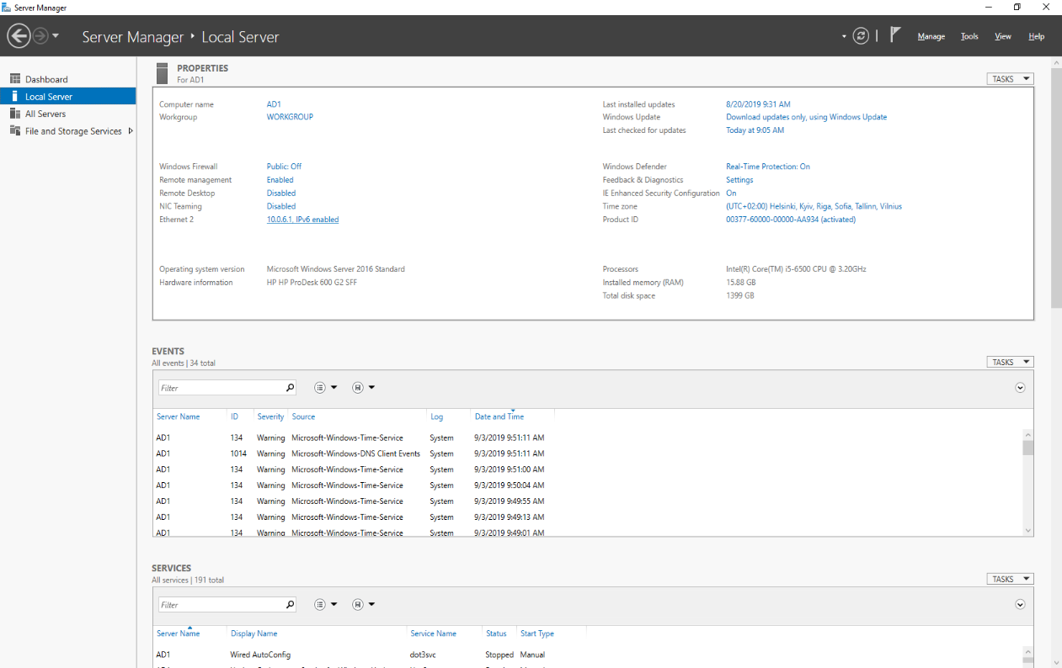

1.1 Change the name for the first computer to AD2

Next, we disabled the Firewall in Control Panel:

* In ”System and Security”, click ”Windows Firewall”.
* Choose ”Turn Windows Firewall on or off” and check both ”Turn off Windows Firewall”.

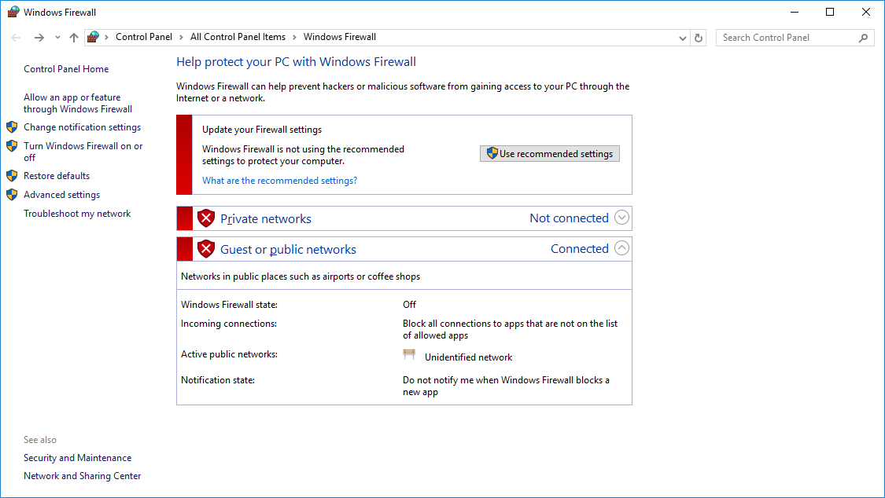

1.2 Firewall disabled

Then we set this first Windows Server a static private IP address; our group had a subnet:

**10.0.6.0/24**, so we followed steps:

* In ”Server Manager”, click ”Ethernet” and choose ”Ethernet” icon.
* In the ”Ethernet Status” window, choose ”Properties” and ”Internet Protocol Version 4 (TCP/IP)” and click ”Properties”.
* Choose ”Use the following IP address:” and fill proper address/mask and default gateway.
* Choose ”Use the following DNS server addresses:”

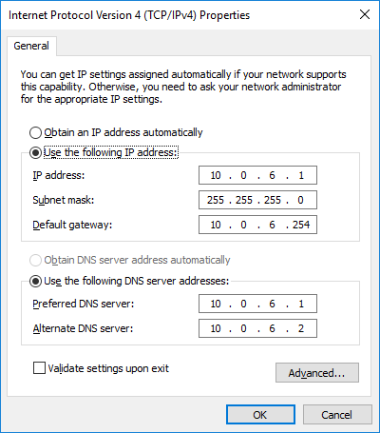

1.3 Change IP address properly

After changing the IP address, we opened Command Prompt to check:

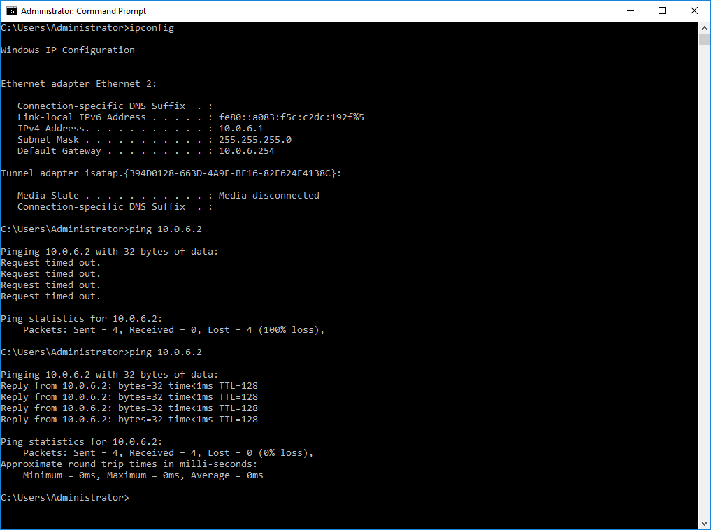

1.4 Check IP address

Installing ADDS:

* In Server Manager program, click ”Manage” -> ”Add Roles and Features”, here:

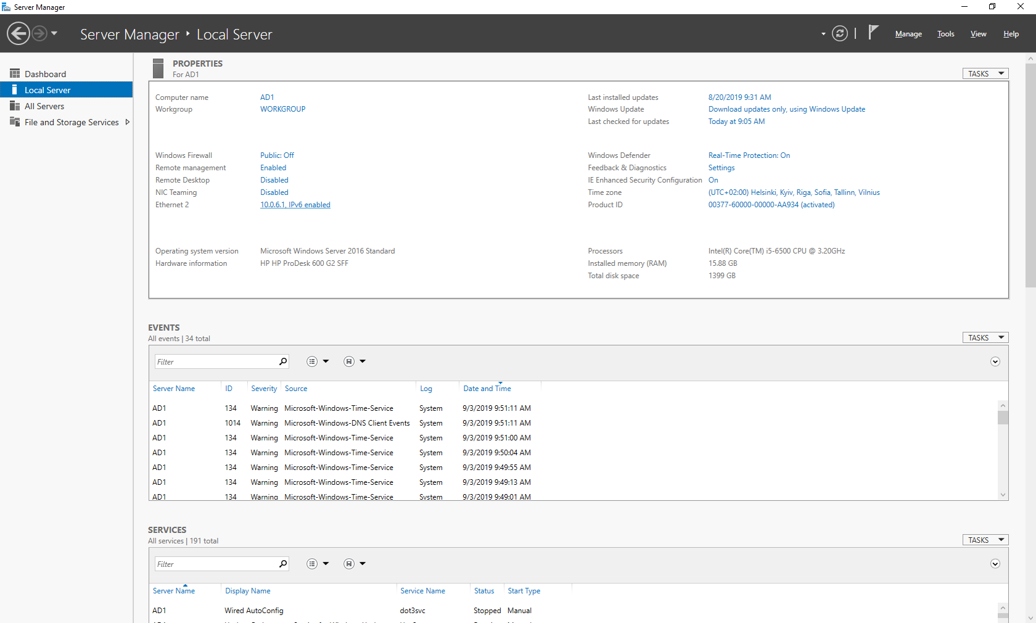

* Then follow step by step in the material